Province : General
Date : 04.08.2017
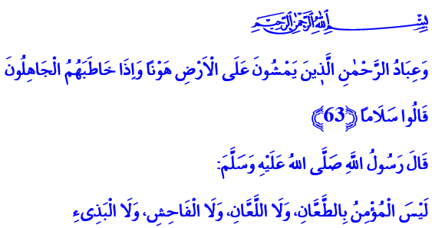
BEING THE DEVOUT SERVANT OF THE MOST MERCIFUL
My Dear Brothers!
Once the Prophet (ﷺ), when talking to his Sahaba, briefly described the good characteristics a Muslim should possess as follows: A believer is like a bee which eats that which is pure and wholesome and lays that which is pure and wholesome. When it lands on something it does not break or ruin it.”
Dear Believers!
Our great Lord praises his servants in the Quran al-Karim. He promises them eternal blessing which no eyes have seen, no ears have heard and no mind has imagined. Come, and let us today in this Khutbah all heed to the traits of those servants, who have been blessed with praise of the most Merciful.
My Brothers!
The devout servants of the most Merciful are those who walk upon the earth with humility. They never act arrogant, get full of themselves or think they are better than others. For they know that the way to betterment goes through being dutiful and responsible to Allah. Getting proud and arrogant, lording over others will only distance the person from the Mercy and pleasure of Allah.
The devout servants of the most Merciful, would abstain from vain speech and actions that has no benefit in this world or the next. They do not heed taunts of the ignorant. They say “Peace” and walk away. For they know that stepping over the line, arrogance and being vulgar, are not actions befitting of a believer. What is fitting of a believer is being considerate, act respectful, be far sighted and not to stray from moderation. His example in this is the warning of our Prophet (ﷺ): “A Muslim cannot be a rude, shameless person who slanders, curses and is bad mouthed.”
My Dear Brothers!
The devout servants of the most Merciful are those who have submit themselves to Allah from the bottom of their hearts. The most open manifestation of this submission is their reverent prostration in the silence of the night. The expressions of their loyalty are the prayers and Istighfar which they direct to Allah with sincerity in the providence of the dawn. They are the ones who plead regretfully from their heart 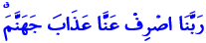 “Our Lord, avert from us the punishment of Hell!” when they sin.
The devout servants of the most Merciful,
are neither stingy nor wasteful. They seek to keep the balance between these two in their spendings. They abstain from wasting the wealth, time, and health which our great Lord has given as a blessing. They believe that one day all blessings that have been given will be brought to account. And when necessary they do not back down from any sacrifice for Allah.
My Dear Brothers!
The devout servants of the most Merciful are always honest and straight as the letter Alif. They do not stray from the Sirat al-Mustaqim for a second. They do not bow before any being other than Allah. They reserve their servitude just to him. They do not let their minds or hearts be imprisoned to any mortal. They do not slay a life decreed Haram by Allah. They do not get involved in adultery. They do not commit actions that would harm the honour or Iffah of a human.
The devout servants of the most Merciful,
abstain from one of the biggest sins, being a false witness. They do not corrupt their minds with bad thoughts. They do not turn their tongues into poisonous arrows by lying and slandering. They do not believe in baseless words or get bothered by bad situations. For they know all of these are the sources of evil, Fitnah and corruption; the reason of all unrest and degeneration. The duty of a believer is to always protect the Truth. To always be at the side of the right. Be the interpreter of the truth.
The devout servants of the most Merciful,
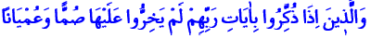 do not turn blind and deaf when they are reminded of the verses of their Lord. They try to understand our book of life, the Qur'an, correctly and to live in accordance with it in the best possible way. They contemplate the universe we live in and the perfect Ayah of Allah, the human. They see life and events that happen as lessons.
My Dear Brothers!
The devout servants of the most Merciful pray “Our Lord, grant us from among our wives and offspring comfort to our eyes and make us an example for the righteous.”
Those will be awarded the highest places of Paradise for their patience. They will be received therein with greetings and peace and abiding eternally therein. What a good settlement and residence this is!
How happy is he who can be the devout servant of the most Merciful! How happy is he, who lives according to the purpose and wisdom of his creation, and wins the pleasure of Allah! How happy is he, who follows the path of peace! How happy is he, who changes this mortal world into an immortal profit!

Ibn Hanbel, II, 199.
Tirmizî, Birr, 48; Ibn Hanbel, I, 405.
Al-Furkân, 25/63-76. Prepared by: Directorate General Bureau of Religious Services

